PRODUCT DATA SHEET

**Alcohol Neutral Silicone Sealant BFT-2987**

|  |
| --- |
| ONE-PART,NEUTRAL-CURING,LOW-MODULUS SEALANT |

**PRODUCT DESCRIPTION**

It is a one-part, neutral-curing, low-modulus silicone sealant with outstanding adhesion, long shelf life and excellent tooling characteristics for construction, perimeter sealing and glazing. It cures at room temperature under the action of atmospheric moisture to give a permanently flexible silicone rubber.

**Uses**

* Sealing of connecting and expansion joints in the building industry
* Sealing of joints between in sanitary applications
* Sealing of joints between glazing and supporting structure(frames, transoms, mullions)
* Industrial sealant for the automotive, aircraft and shipbuilding industries
* Sealant for technical applications: e.g. for mechanical engineering and for container and silo construction.

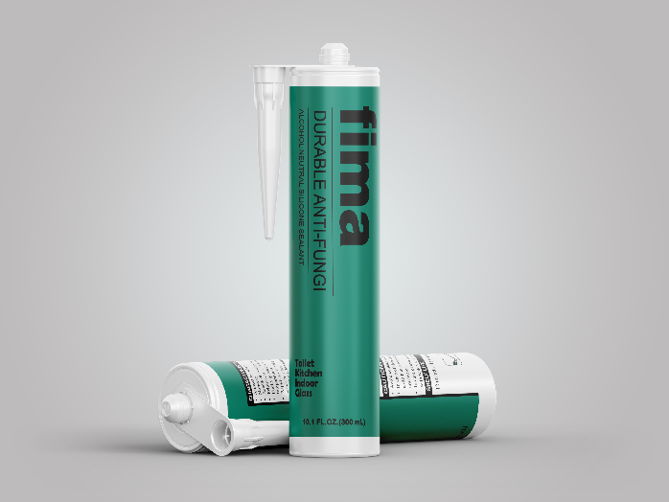

.**CHARACTERISTICS/ADVANTAGE**

* Almost odorless
* Long shelf life
* non-sag
* excellent tooling haracteristics for professional use
* primer less adhesion to most materials
* readily gunnable both at low(+5°C)and high(+40°C) temperatures
* rapid cross linking: quickly becomes tack-free and crack resistant
* flexible at low(-40°C)and high temperatures(+150°C)following cure
* excellent weather ability
* non-corrosive to metal suitable for alkaline substrates such as concrete, mortar, fibrous cement

**TECHNICAL INFORMATION & TESTING**

|  |  |  |
| --- | --- | --- |
| **PRODUCT INFORMATION** | | |
| Packaging | 300ml(480g) per pieces  24 pieces per box | |
| Shelf Life | 15 months if stored below 25℃ | |
| Service temperature | -40℃ to +150℃ | |
| Application temperature | 5℃ to +40℃（Ambient） | |
| Color | White/Black | |
| **PROPERTY** | **VALUE** | **TEST METHOD** |
| Chemical base | Alcohol Neutral silicone |  |
| Density （uncured） | ~1.02 kg/l (value at +25 °C) | ISO/R 1183 |
| **Properties Uncured** | | |
| Skin formation time | 8 minutes | ISO 7390,  profile U 20 |
| Consistency | Non-sag |
| Extrusion rate - volume flow | 500 ml/min |
| **Cured Mechanical Properties** | | |
| Shore A Hardness | 19 | ISO 868 |
| Elongation to Break | 300% | ISO 37 –  S2 (2 mm film) |
| Tear strength | 1.30 N/mm² |

Results may differ based upon statistical variations depending upon mixing methods and equipment, temperature, application methods, test methods, actual site conditions and curing conditions

**Application Instructions**

**Surface preparation**

The substrate areas that will be in contact with the sealant must be clean, dry and free of all loose material, dust, dirt, rust,oil and other contaminants.Non-porous substrates should be cleaned with a solvent and a clean, lint-free, cotton cloth. Wipe dry immediately with another such cloth before the solvent evaporates from the surface.

**Adhesion**

It exhibits excellent primer less adhesion to most non-porous siliceous material, e.g. glass, tiles, ceramics, enamel, glazed tiles and clinker; impregnated,varnished or painted wood; and some plastics. Users must carry out their own tests due to the great variety of substances.The adhesion can be improved in many cases by pretreatment of the substrates with a primer.If adhesion difficulties arise please contact our technical service