PRODUCT DATA SHEET

**BFT-2305® SILICONE SEALANT**

|  |
| --- |
| HIGH PERFORMANCE SILICONE WEATHERPROOFING SEALANT |

**PRODUCT DESCRIPTION**

305 SILICONE SEALANT is a durable neutral-curing silicone sealant with a high movement capability and good adhesion to a wide range of substrates. It is particularly suited as a weather seal for structural glazing, curtain walling and windows.

**Uses**

* Durability & weatherproofing sealing under severe conditions
* weather seal for structural glazing, curtain walling and windows.

**Note**

This product is suitable for experienced professional users only. Tests with actual substrates and conditions have to be performed to ensure adhesion and material compatibility

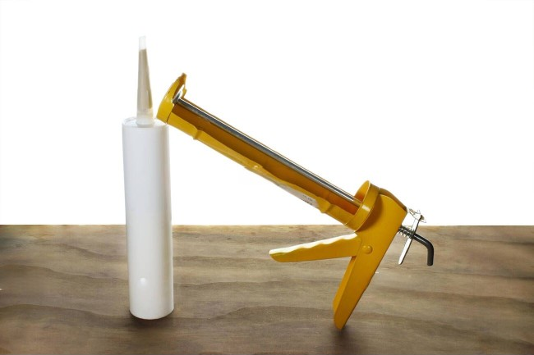

.**CHARACTERISTICS/ADVANTAGE**

* Very good UV and weathering resistance
* Adheres well to many substrates including glass, metals, coated and painted metals, plastics and wood.

**APPROVALS / STANDARDS**

* GB/T 14683-2017
* ASTM C920 for Type S, Grade NS, Class 50 (movement capability ± 50 %)

**TECHNICAL INFORMATION & TESTING**

|  |  |  |
| --- | --- | --- |
| **PRODUCT INFORMATION** | | |
| Packaging | 300ml(480g) per pieces  24 pieces per box | |
| Shelf Life | 15 months if stored below 25℃ | |
| Service temperature | -40℃ to +150℃ | |
| Application temperature | 5℃ to +40℃（Ambient） | |
| Color | White/Black | |
| **PROPERTY** | **VALUE** | **TEST METHOD** |
| Chemical base | 1-component silicone |  |
| Density （uncured） | ~1.40 kg/l (value at +25 °C) | ISO/R 1183 |
| **Curing** | | |
| Skin time | 45 minutes | JB/T 7311 |
| Tack free time | 140 minutes |
| Mechanism | Moisture-curing |
| Cure type | Neutral |
| **Cured Mechanical Properties** | | |
| Shore A Hardness | 25 | GB/T 531 / ISO 7619 |
| Tensile Strength | 1.5MPa | GB/T 528 / ISO 37 |
| 100% modulus | 0.4MPa |
| Elongation to Break | 600% |
| Tear strength | 8N/mm | GB/T 529 / ISO 34 |

Results may differ based upon statistical variations depending upon mixing methods and equipment, temperature, application methods, test methods, actual site conditions and curing conditions

PRODUCT DATA SHEET

**Application Instructions**

**Surface preparation**

Surfaces must be clean, dry and free from grease, oil and dust. Surface treatment depends on the specific nature of the substrates and is crucial for a long lasting bond.

**Application**

The optimum temperature for substrate and sealant is between 15 °C and 25 °C.

305 SILICONE SEALANT can be processed with manual, pneumatic or electric driven piston guns.

Joints must be properly dimension ed.

For optimum performance the joint width needs to be designed according to the movement capability of the sealant based on the actual expected movement. The minimum joint depth is 6 mm and a width / depth ratio of minimum 2 : 1 and maximum 4 : 1 must be respected.

Joints deeper than 15 mm must be avoided.

For back filling, it is recommended to use closed cell, sealant compatible foam backer rods e.g. high resilience polyethylene foam rod. If joints are too shallow for backing material to be employed, we recommend using a polyethylene tape. This acts as a release film (bond breaker), allowing the joint to move and the silicone to stretch freely.

**Tooling and finishing**

Tooling and finishing must be carried out within the skin time of the sealant.

When tooling freshly applied 305 SILICONE SEALANT , press the sealant to the joint flanks to get a good wetting of the bonding surface. No tooling agents to be used.

**Removal**

Uncured 305 SILICONE SEALANT can be removed

from tools and equipment suitable solvents. Once cured, the material can only be removed

mechanically.

Hands and exposed skin have to be washed immediately using hand wipes or industrial hand cleaner and water.

Do not use solvents on skin.

**Limitations**

For specific information regarding compatibility between various BLF products contact the Technical Department of BLF Industry.

To exclude materials influencing 305 SILICONE SEALANT, all materials such as gaskets, tapes, setting blocks, sealants, etc., in direct and indirect contact have to be approved by BLF in advance.

Where two or more different reactive sealants are used, allow the first to cure completely before applying the next. 305 SILICONE SEALANT, may only be used in combination with structural glazing applications after a detailed examination of the corresponding project details.

Do not use 305 SILICONE SEALANT on PMMA and PC elements as it may cause environmental stress cracking (crazing)

PRODUCT DATA SHEET

THE MATERIALS, PRODUCTS AND SERVICES OF MOMENTIVE PERFORMANCE MATERIALS INC. AND ITS SUBSIDIARIES AND AFFILIATES (COLLECTIVELY “SUPPLIER”), ARE SOLD SUBJECT TO SUPPLIER’S STANDARD CONDITIONS OF SALE, WHICH ARE INCLUDED IN THE APPLICABLE DISTRIBUTOR OR OTHER SALES AGREEMENT, PRINTED ON THE BACK OF ORDER ACKNOWLEDGMENTS AND INVOICES, AND AVAILABLE UPON REQUEST. ALTHOUGH ANY INFORMATION, RECOMMENDATIONS, OR ADVICE CONTAINED HEREIN IS GIVEN IN GOOD FAITH, SUPPLIER MAKES NO WARRANTY OR GUARANTEE, EXPRESS OR IMPLIED, (i) THAT THE RESULTS DESCRIBED HEREIN WILL BE OBTAINED UNDER END-USE CONDITIONS, OR (ii) AS TO THE EFFECTIVENESS OR SAFETY OF ANY DESIGN INCORPORATING ITS PRODUCTS, MATERIALS, SERVICES, RECOMMENDATIONS OR ADVICE. EXCEPT AS PROVIDED IN SUPPLIER’S STANDARD CONDITIONS OF SALE, SUPPLIER AND ITS REPRESENTATIVES SHALL IN NO EVENT BE RESPONSIBLE FOR ANY LOSS RESULTING FROM ANY USE OF ITS MATERIALS, PRODUCTS OR SERVICES DESCRIBE HEREIN.